**EASTERN INTERNATIONAL UNIVERSITY**

**SCHOOL OF COMPUTING AND INFORMATION TECHNOLOGY**

**DEPARTMENT OF COMPUTING AND INFORMATION TECHNOLOGY**



**PROJECT REPORT**

**BUILDING A WEBSITE TO BUY HERBAL (HERBAL HEALERS WEBSITE)**

**Student**

Trần Khánh Bình – 2231200127

**Supervisor**

Trần Thị Như Quỳnh

**Binh Duong, December, 2024**

**EASTERN INTERNATIONAL UNIVERSITY**

**SCHOOL OF COMPUTING AND INFORMATION TECHNOLOGY**

**DEPARTMENT OF COMPUTING AND INFORMATION TECHNOLOGY**



**PROJECT REPORT**

**BUILDING A WEBSITE TO BUY HERBAL (HERBAL HEALERS WEBSITE)**

**Student**

Trần Khánh Bình – 2231200127

**Supervisor**

Trần Thị Như Quỳnh

**Binh Duong, December, 2024**

# ABSTRACT

The rising demand for online herbal product sales underscores the need for a reliable and user-friendly platform to manage inventory, customer interactions, and order processing. Traditional herbal product distribution methods often encounter challenges such as scalability, data inaccuracies, and lack of personalized customer engagement. To address these gaps, this project focuses on developing a Herbal Management Website that simplifies operations while enhancing user satisfaction. The platform is built with a robust tech stack, utilizing Node.js and Express.js for efficient backend processing and RESTful API integration, a MySQL database for secure and structured data management, and a responsive user interface crafted with HTML, CSS, JavaScript, and Bootstrap. Key features include CRUD functionalities for product management, user registration, login systems, and an admin panel for role and permission management. Additionally, real-time chat functionality bridges communication between doctors and customers, promoting personalized support and care. The project follows an agile development methodology, ensuring iterative improvements based on user feedback and business needs. Comprehensive system design artifacts, such as user stories, class diagrams, and database schema, align the platform with modern business objectives. Initial milestones include the successful implementation of product CRUD operations, basic login features, and seamless database integration. Looking ahead, the project aims to expand its functionality with features like detailed order tracking, advanced chat support, and enhanced reporting tools. By blending modern web technologies with user-centric design principles, the Herbal Management Website demonstrates a scalable and efficient solution, showcasing the potential to revolutionize traditional herbal product distribution and improve operational efficiency.

**Acknowledgement**

I would like to extend my sincere gratitude to Ms. Tran Thi Nhu Quynh for her invaluable assistance in completing this project. Her expertise and guidance have been crucial in helping us navigate challenges and achieve our objectives. Ms. Quynh's dedication and willingness to share her knowledge have greatly enhanced our work, and her mentorship has been a source of inspiration for the entire project. I deeply appreciate her unwavering support and commitment, which have been the primary key to the success of our project. Working with Ms. Tran Thi Nhu Quynh has been a privilege, and her contributions have made a lasting impact. Thank you for all your excellent advice and support throughout this journey

**TABLE OF CONTENTS**

Abstracti

Acknowledgementii

Table of contentsiii

List of Figures v

List of Tables vii

List of Abbreviations viii

CHAPTER 1. OVERVIEW 1

* 1. Introduction 1
  2. Project Objectives 1
  3. Related Works 2
  4. Challenge 3
  5. Report Structures 3

CHAPTER 2. TECHNOLOGIES 4

* 1. HTML5 4
  2. CSS 5
  3. JavaScript 6
  4. Bootstrap 7
  5. Node.js 8
  6. Express.js 8
  7. My SQL Server Workbench 10

CHAPTER 3. ANALYSIS AND DESIGN 11

* 1. Use Case Diagram 11
  2. Database Diagram 16
  3. Database Table 17

CHAPTER 4. RESULTS 20

* 1. Installation Environment 20
  2. Results and Discusstion 20
  3. Home Page 21
  4. Product Page 23
  5. CRUD 28
  6. Login - Sign up Page 29

CHAPTER 5. CONCLUSION AND FUTURE WORKS 30

* 1. Result 30
  2. Future works 30

REFERENCES 32

**TABLE OF FIGURES**

Figure 1: HTML5 Logo 4

Figure 2: CSS Logo 5

Figure 3: JavaScript logo 6

Figure 4: Bootstrap Logo 7

Figure 5: Node.js Logo 8

Figure 6: Express.js Logo 9

Figure 7: My SQL Server Logo 10

Figure 8: Admin Use Case 11

Figure 9: System User Use Case 12

Figure 10: Customer Use Case 14

Figure 11: Doctor Use Case 15

Figure 12: Herbal Website Database Diagram 16

Figure 13: Home page 1 21

Figure 14: Home page 2 21

Figure 15: Home page 3 22

Figure 16: List Product 23

Figure 17: Product Page 23

Figure 18: More detailed product 24

Figure 19: Product Information 24

Figure 20: Discuss and Share Product 25

Figure 21: Review 25

Figure 22: Newspaper about Herba 26

Figure 23: Service Cham Cuu 26

Figure 24: Product Item 27

Figure 25: Add to Cart 27

Figure 26: CRUD Product page 28

Figure 27: Contact us Page 28

Figure 28: Login page 29

**LIST OF TABLES**

Table 1: Product table 17

Table 2: Cart table 17

Table 3: CartItems Table 18

Table 4: Inventory Table 18

Table 5: Purchase Orders Table 18

Table 6: User Table 19

# LIST OF ABBREVIATIONS

|  |  |  |
| --- | --- | --- |
| **No.** | **Term** | **Meaning** |
| 1 | CSS | Cascading Style Sheets |
| 2 | SQL | Structured Query Language |
| 3 | API | Application Programming Interface |
| 4 | HTTPS | Hypertext Transfer Protocol Secured |
| 5 | HTML | Hypertext Markup Language |
| 6 | GPS | Global Positioning System |
| 7 | JSON | JavaScript Object Notation |
| 8 | SDK | Software Development Kit |
| 9 | CRUD | Create, Read, Update and Delete |

**Chapter 1. Overview**

### Introduction

The management of herbal products is a vital aspect of ensuring quality, sustainability, and efficient distribution in today’s health-conscious markets. With increasing consumer demand for natural remedies and herbal supplements, businesses face challenges in optimizing their operations while maintaining product integrity and compliance with health standards. Traditional methods of managing herbal inventories—often manual and fragmented—struggle to keep pace with the complexities of modern operations, including real-time stock updates, accurate product categorization, and seamless integration with distribution networks.

Recognizing these challenges, this project introduces a comprehensive **Herbal Healers System (HHS)**, designed to revolutionize the way herbal businesses operate. By leveraging automation, data-driven insights, and a modular architecture, HHW streamlines operations and ensures efficiency. With its user-friendly design and cutting-edge features, the system empowers businesses to manage their herbal products effectively, ensuring quality and accessibility for their customers.

Our vision is to transform herbal management by enhancing inventory accuracy, minimizing manual errors, and providing real-time analytic to support decision-making. Features such as product categorization, stock management, order tracking, and detailed reporting enable businesses to optimize their workflows, meet consumer demands, and uphold the highest standards of service and quality in the herbal industry.

### Project objectives

This project aims to develop a Herbal Healers Website (HHW) tailored to address the challenges faced in traditional herbal product management. The primary goal is to provide a streamlined platform that simplifies product inventory management, enhances user experience, and supports business scalability.

The HHW emphasizes user-centric design by incorporating a clean and responsive interface built using HTML, CSS, JavaScript, and Bootstrap. This design enables seamless navigation and interaction. The back-end is powered by Node.js and Express.js, ensuring stable performance and efficient data handling. The system relies on a MySQL database for secure and structured data storage, with RESTful APIs facilitating communication between components.

Key features implemented in the system include CRUD operations for herbal products, user registration and login functionality, role-based access management, and real-time order tracking. Additionally, the platform supports an admin panel for managing system roles and a doctor-patient chat feature to enhance personalized user interactions.

The development follows the Agile methodology to ensure adaptability and continuous improvement. Current progress includes the completion of essential CRUD functionalities and a foundational database schema. Future phases will focus on enhancing features like detailed order management and advanced reporting tools to meet business needs effectively.

### 1.3 Related works

During the development of our **Herbal Healers Website (HHW)**, we conducted a survey of existing solutions on the market in 2024 to understand common functionalities and identify unique features for our product. Below are some notable herbal-related websites and their systems[1]:

* **Agarwood.org.vn**: This website offers a comprehensive platform for managing and selling agarwood products. It provides inventory management, product tracking, and real-time updates on stock levels, ensuring efficient operations for businesses.
* **Khothuocnamonline.com**: A specialized platform for the sale and distribution of herbal products. This website focuses on managing a wide range of herbal remedies, offering features like detailed product listings, stock management, and cloud-based data storage to ensure seamless access across devices.
* **Chuthapdo.org.vn**: A nonprofit organization providing herbal medicine and healthcare solutions. The website integrates basic inventory management with the distribution of health-related products, allowing for efficient tracking of orders and stock levels, as well as an easy-to-navigate interface for users.

The above solutions typically offer basic functionalities such as inventory tracking, product listing, and order management. However, our **Herbal Healers Website (HHS)** aims to enhance these processes by applying new technology, offering a more user-friendly interface, and providing high customization to meet the specific needs of herbal businesses.

### 1.4 Challenge

While notable progress has been made in the development of the Herbal Management System (HMS), several challenges have emerged during the project:

* **Limited Database Knowledge:** As the project involved learning and implementing database concepts from scratch, this required significant time and effort to grasp the fundamentals while simultaneously applying them.
* **Balancing Learning and Development**: With limited experience in technologies like Node.js, Express.js, and MySQL, learning new tools while meeting project deadlines was a demanding task..
* **Limited Resources and Time Constraints**: Managing the extensive development requirements within the restricted timeline meant prioritizing essential features over advanced functionalities.

Despite these challenges, the project has achieved its core objectives, laying a strong foundation for future development and feature expansion..

### 1.5 Report Structure

To ensure a comprehensive understanding of the Herbal Management System (HMS), the report is organized into five chapters:

* **Chapter 1**: Overview: Introduces the project, outlining its motivation, objectives, challenges, and scope..
* **Chapter 2**: Technologies: Provides insights into the tools and frameworks used, detailing how they contribute to the project's goals..
* **Chapter 3**: Analysis and Design: Covers system design, database structure, and class diagrams, offering a detailed explanation of the system's architecture.
* **Chapter 4**: Results and Discussion: Highlights the implementation process, showcasing key functionalities achieved, discussing challenges encountered, and evaluating project outcomes.
* **Chapter 5**: Conclusion and Future Work: Summarizes the project's findings, key takeaways, and outlines potential improvements and features for future development.

This structured approach ensures a logical progression, offering clarity on the project's journey from conception to completion.

**Chapter 2. Technologies**

### HTML5

* + 1. **What is HTML5?**

HTML is the standard markup language used to create the structure and content of web pages. It consists of a series of elements, each enclosed in angle brackets, which define the different parts of a web page's content. These elements can represent headings, paragraphs, images, links, forms, and more.[2]



Figure 1: HTML5 Logo

* + 1. **Key points:** 
       - **Enhanced Semantics**: HTML5 introduces semantic elements like <header>, <footer>, <article>, and <section>, which improve code readability and structure, making it easier to maintain and scale the project.Every browser supports HTML Language.
       - **Rich Multimedia Support**: HTML5 natively supports multimedia elements like <audio> and <video>, eliminating the need for third-party plugins and enabling a modern, interactive user experience.Loose syntax.

HTML5 is heavily used for creating Web pages and documents, alongside navigation on the Internet. It can also be utilized for responsive images using various img elements, as well as assisting with client-side storage through local Storage and Index Db.[3]

### CSS

* + 1. **What is CSS?**

CSS (Cascading Style Sheets) describes how HTML elements are to be displayed. It controls the layout of multiple web pages at once and it is used to define styles for various elements, including the design, layout and variations of display for different devices and screen sizes.



Figure 2: CSS Logo

* + 1. **Key points:** 
       - **Design and Styling**: CSS allows for complete control over the visual presentation of the website, ensuring a responsive, aesthetically pleasing design tailored to user needs..
       - **Efficiency through Reusability**: Styles can be defined once and reused across multiple pages, reducing duplication and maintaining consistency throughout the application.
       - **Advanced Features**: With CSS3, features like animations, transitions, and media queries make it easier to create interactive designs and responsive layouts.

CSS is used widely in most web pages and applications, mostly for controlling style

elements such as effects, flash animations, colors, etc. It also plays a part in managing

dynamic web templates, especially for applications in social media, e-commerce, and

other user-side interfaces.

### JavaScript

* + 1. **What is JavaScript?**

JavaScript is a programming language that is one of the core technologies of the World Wide Web. It allows you to implement complex and interactive features on web pages i.e. displaying timely content updates, interactive maps, animated 2D/3D graphics, scrolling video jukeboxes, etc. Along with HTML and CSS, it completes the front-end package for an interactive and user-friendly interface.[3]



Figure 3: JavaScript logo

* + 1. **Key points:** 
       - **Dynamic Interactivity**: JavaScript enables real-time interactivity on the website, such as validating user input, handling dynamic content updates, and implementing animations.
       - **Cross-Platform Functionality**: It runs seamlessly on any web browser without additional plugins, ensuring consistent user experiences across devices.
       - **Integration with Backend**: JavaScript facilitates communication with the backend via APIs, using technologies like AJAX or Fetch for data fetching and manipulation without reloading the page.
* Dynamic Web development and Interactive behavior in websites.
* Mobile applications.
* Artificial Intelligence.
* Analytic.

### Bootstrap

* + 1. **What is Bootstrap?**

Bootstrap is a front-end framework for building responsive websites. Whether it is application frameworks, blogs, or other CMS applications, Bootstrap can be a good fit, as it can be as vanilla as you like. Its combination of HTML, CSS, and JavaScript make it easy to build robust sites without adding a lot of code. With a default grid system, layouts come together with ease, and the styling of buttons, navs, and tables make basic markup look great from the get-go.[4]

Figure 4: Bootstrap Logo



* + 1. **Key points:** 
       - **Rapid Development**: Bootstrap provides pre-designed components and a grid system, speeding up the development process and reducing the time needed to build responsive designs..
       - **Customization and Scalability**: Bootstrap can be customized to match the project’s branding and requirements, making it both flexible and scalable for future development.
       - **Integration with Other Tools**: Bootstrap integrates seamlessly with popular frontend frameworks like Angular, React, and Vue, providing additional flexibility and functionality.

This combination of features makes Bootstrap an invaluable tool for building modern, responsive, and scalable web applications efficiently..

### Node.js

* + 1. **What is Node.js?**

Node.js is a powerful and popular new framework for writing scalable network programs using JavaScript. It allows developers to create high-performance servers and networking tools with ease. Node.js operates on a single-threaded, event-driven architecture, which is designed to optimize throughput and scalability in web applications with many input/output operations. This non-blocking I/O model makes it lightweight and efficient, perfect for data-intensive real-time applications that run across distributed devices.[5]

Figure 5: Node.js Logo

* + 1. **Key points:** 
       - ****Scalability****: Node.js handles many simultaneous connections efficiently, making it ideal for large-scale systems.Provides direct control to many elements.
       - ****Full-stack development****: Developers can use a single language (JavaScript) for both frontend and backend.
       - **A**ctive Ecosystem****: Node.js has a vast package library to accelerate development.
       - **High Performance**: Node.js uses a non-blocking, event-driven architecture, making it highly efficient for handling multiple requests simultaneously in real-time applications.

.

### Express.js

* + 1. **What is Express.js?**

"Express.js is a minimal and flexible Node.js web application framework that provides a robust set of features for web and mobile applications. It facilitates the rapid development of Node-based web applications by providing a thin layer of fundamental web application features, without obscuring Node.js features. Express.js comes with a myriad of HTTP utility methods and middleware, creating a robust API that is easy to use and highly customizable. This framework allows developers to build single-page, multi-page, and hybrid web applications with ease.[6]

Figure 6: Express.js Logo

**2.6.2 Key points:**

* + - * **Simplicity: Express.js simplifies server creation with minimal boilerplate code, allowing us to focus on application logic rather than complex configurations.**F**lexible and Extensible**: Express allows you to add various middleware and third-party modules to enhance functionality, such as request parsing, logging, authentication, and more.
      * **Easy Routing and Handling**: With Express.js, routing is simplified, allowing developers to define routes for handling various HTTP methods (GET, POST, PUT, DELETE, etc.) with minimal code.

### My SQL Server Workbench

* + 1. **What is SQL Server Workbench?**

**MySQL** is an open-source relational database management system (RDBMS) developed by Oracle Corporation. It stores and retrieves data as requested by other software applications, and its name is descriptive, being server software that responds to queries in SQL language. MySQL provides various visual interfaces, tools, and options, making it easy to manage and operate databases.[7]



Figure 7: My SQL Server logo

* + 1. **Key points:** 
       - **Increase Data Security:** MySQL ensures the safety of databases, especially with features like user authentication and permission controls.
       - **Ease of Configure:** Compared to other database management systems, MySQL offers a simpler installation and configuration process, making it easy to set up.
       - **Optimized Data Storage:** If issues like power outages or server shutdowns occur, MySQL minimizes the risk of data loss by providing features for data recovery and restoration.
       - **Data Recover Support:** If the power interruption or server shutdowns occurs data may be corrupted so Microsoft SQL Server eliminates the risk of losing data by having features for data recovery and restoration.

**Chapter 3. Analysis and Design**

### Use Case Diagram

**3.1.1.Admin Use Case**

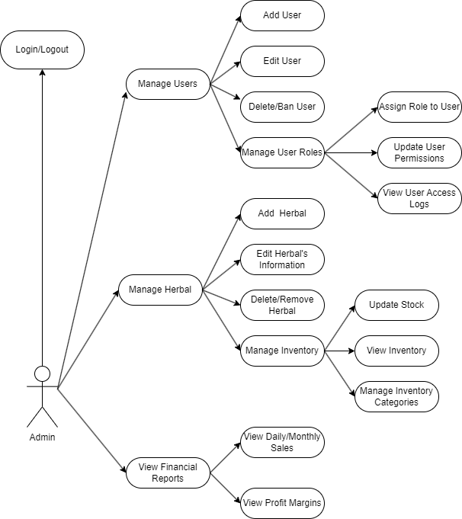Figure 8: Admin Use Case

For admin role, the system design clearly communicates the critical role the Admin plays in user account management, permission assignment, and maintaining comprehensive system access.

* **Manage Account for User**: the Admin has the capability to create user accounts within the Herbal Management System. This allows them to onboard new customers and grant them access to the necessary system functionalities.
* **Assign User Permissions**: in addition to creating user accounts, the Admin can assign specific permissions and access levels to the Manager and Staff roles. This ensures that users are only able to perform the tasks and access the information relevant to their respective responsibilities.
* **Full Access to All Functions in the System**: as the highest-level user, the Admin has full and unrestricted access to all the functionalities and data within the Herbal Management System. This allows the Admin to oversee, manage, and maintain the overall operations of the system.

**3.1.2.System User Use Case:**

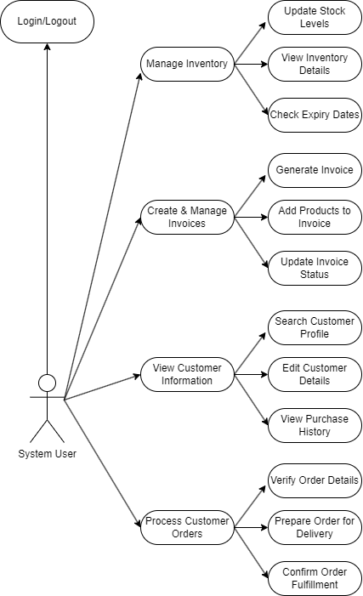Figure 9: System User Use Case

It provide a comprehensive overview of the System User's core functionalities within the Herbal Management System:

* **Manage Inventory Information:** System User is responsible for overseeing and maintaining the accuracy of the inventory information within the system. This includes tracking stock, monitoring product details, and ensuring the integrity of inventory records.
* **Manage Suppliers Information:** the System User handles the management of supplier - related information, including on boarding new suppliers, updating existing supplier details, and maintaining accurate supplier records.
* **Same Functionalities with Staff Role:** the System User provides certain core information to the Admin role.
* **Approve for the Import Products:** the System User has the authority to approve the import of new products into the herbal inventory. This ensures that only authorized and appropriate items are added to the system.
* **Receive the Inventory Alert for too much or too low:** the System User is notified of inventory level alerts, indicating when stock quantities are either too high or too low. This allows the System User to take proactive measures to address inventory imbalances.

**3.1.3.Customer Use case:**

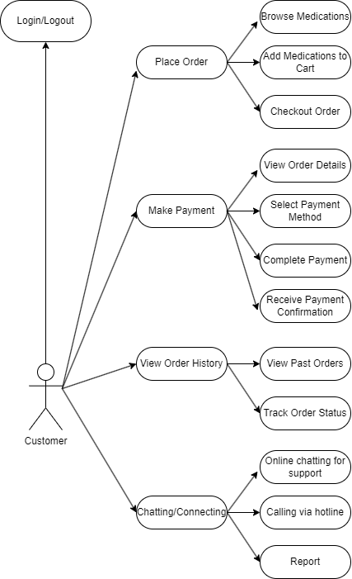Figure 10: Customer Use Case

The system design emphasizes creating a seamless shopping experience for the Customer, ensuring they can efficiently browse and purchase products while maintaining clear communication with doctors for consultation.

* **Place Orders:** Customers can browse the product catalog, add items to their cart, and place orders for their selected herbal products. The system provides a user-friendly interface to streamline the purchasing process.
* **Make Payments:** After placing an order, customers can choose from multiple payment methods, including online and cash-on-delivery options, ensuring flexibility and convenience.
* **Track Orders and View Purchase History:** Customers can monitor the real-time status of their orders, from confirmation to delivery. Additionally, the system offers a purchase history feature for easy reference to past orders.
* **Chat and Contact Doctors:** For personalized consultation, customers can directly chat with doctors via the system. This feature allows them to discuss their health conditions, get recommendations, and ensure the products they purchase are suitable for their needs.

**3.1.4.Doctor Use case**

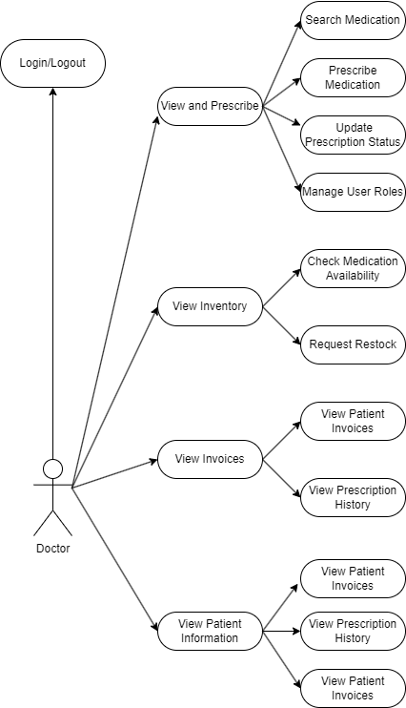

Figure 11: Doctor Use Case

The system design for the Doctor role highlights the ability to manage communication with patients, access product details, and provide expert guidance through the platform.

* **Manage and Respond to Chats:** Doctors can view and manage chats with customers or patients after they are categorized by user type. This ensures doctors focus on relevant cases effectively.
* **Browse and Review Products:** Doctors can access the inventory of herbal products, including detailed descriptions, pricing, and availability, to recommend suitable products to their patients.
* **Consultation through Chat or Calls:** Doctors have the capability to provide expert consultation via chat or voice/video calls, enabling a more personalized and effective interaction.
* **Access Customer Contact Information:** Doctors can view the contact details of customers or patients who have reached out, facilitating smoother follow-ups .

**3.2 Database Diagram**

MySQL is a powerful and widely used open-source relational database management system (RDBMS) ideal for management websites. In this stage of project, we organize the database base on the services. Let start with **herbal_services:**

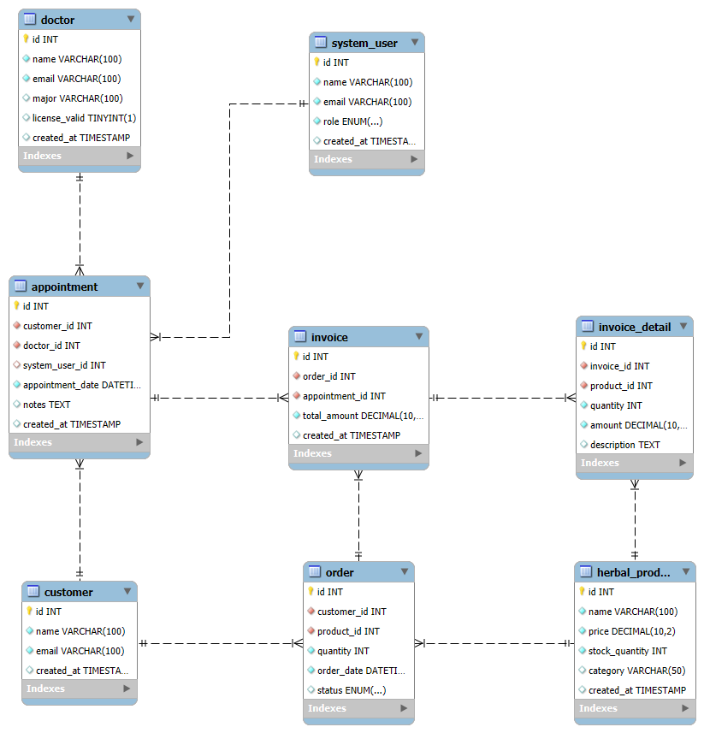Figure 12: Herbal Website Database Diagram

### 3.3 Database Table

**3.3.1 Product Table**

The table used to store herbal products in the system.

Table 1. Product table

|  |  |  |  |
| --- | --- | --- | --- |
| **No.** | **Field Name** | **Type** | **Description** |
| 1 | product_id | INT AUTO_INCREMENT | Unique identifier for the herbal product |
| 2 | Name | VARCHAR(255) | Name of the herbal product |
| 3 | Description | TEXT | Detailed description of the product |
| 4 | Category | VARCHAR(100) | Category of the herbal product |
| 5 | price_per_kg | DECIMAL(10,2) | Price per kilogram of the product |
| 6 | price_per_g | DECIMAL(10,2) | Price per gram of the product |
| 7 | stock_quantity | INT | Number of products available in stock |
| 8 | image_url | VARCHAR(255) | URL path to the product image |
| 9 | created_at | TIMESTAMP | Timestamp the product was created |
| 10 | updated_at | TIMESTAMP | Timestamp the product was last updated |

**Orders table**

The table used to store Orders in the system.

Table 2. Cart table

|  |  |  |  |
| --- | --- | --- | --- |
| **No.** | **Field Name** | **Type** | **Description** |
| 1 | order_id | INTEGER | Unique identifier for the order |
| 2 | customer_id | INTEGER | ID of the customer who placed the order |
| 3 | order_date | TIMESTAMP | Date and time when the order was placed |
| 4 | status | TEXT | Current status of the order |
| 5 | shipping_address | TEXT | Shipping address for the order |
| 6 | tracking | VARCHAR(50) | Tracking number for the order |

**Order Item table**

The table used to store the item of Orders in the system.

Table 3. CartItems Table

|  |  |  |  |
| --- | --- | --- | --- |
| **No.** | **Field Name** | **Type** | **Description** |
| 1 | order_item_id | INTEGER | Unique identifier for the order item |
| 2 | order_id | INTEGER | ID of the order the item belongs to |
| 3 | product_id | INTEGER | ID of the product in the order |
| 4 | quantity | INTEGER | Quantity of the product ordered |

**Inventory table**

The table used to store the Inventory in the system.

Table 4. Inventory Table

|  |  |  |  |
| --- | --- | --- | --- |
| **No.** | **Field Name** | **Type** | **Description** |
| 1 | inventory_id | INTEGER | Unique identifier for the inventory record |
| 2 | product_id | INTEGER | ID of the product in the inventory |
| 3 | location_id | INTEGER | ID of the location where the product is stored |
| 4 | quantity | INTEGER | Current quantity of the product in stock |
| 5 | batch_no | VARCHAR(50) | Batch number for the product |
| 6 | expiry_date | DATE | Expiry date of the product |

**Purchase Orders table**

The table used to store the Purchase Orders in the system.

Table 5. Purchase Orders Table

|  |  |  |  |
| --- | --- | --- | --- |
| **No.** | **Field Name** | **Type** | **Description** |
| 1 | herbal_id | INTEGER | Unique identifier for the purchase order |
| 2 | supplier_id | INTEGER | ID of the supplier the order is from |
| 3 | product_id | INTEGER | ID of the product in the order |
| 4 | quantity | INTEGER | Quantity of the product ordered |
| 5 | unit_price | DECIMAL(10,2) | Unit price of the product |
| 6 | order_date | TIMESTAMP | Date and time when the order was placed |
| 7 | expected_date | TIMESTAMP | Expected delivery date for the order |
| 8 | status | ENUM | Status of the purchase order |
| 9 | total_amount | DECIMAL(10,2) | Total amount of the purchase order |

**Users Table**

The table used to store the Purchase Orders in the system.

Table 6. User Table

|  |  |  |  |
| --- | --- | --- | --- |
| **No.** | **Field Name** | **Type** | **Description** |
| 1 | id | INTEGER | Unique identifier for the user |
| 2 | username | VARCHAR(250) | Username for the user account |
| 3 | email | VARCHAR(250) | Username for the user account |
| 4 | password | VARCHAR(250) | Hashed password for the user account |
| 5 | is_staff | BOOLEAN | Whether the user has staff privileges |
| 6 | created_at | TIMESTAMP | Timestamp when user account was created |
| 7 | updated_at | TIMESTAMP | Timestamp when user account was last updated |
| 8 | is_active | BOOLEAN | Whether the user account is active |
| 9 | last_login | BOOLEAN | Timestamp of the user's last login |

**Chapter 4. Results and Discussion**

**4.1 Installation Environment**

The installation environment plays a crucial role in determining the performance and functionality of the e-commerce platform. To configuration of the environment necessary, we set up the following environment:

1. Operating System: Window 11
2. Java Development Kit (JDK): Java 17 and is compatible up to and including Java 21
3. Integrated Development Environment (IDE): IntelliJ IDEA Ultimate Edition
4. Framework: Spring 6.1.4 or above is also required
5. Spring Framework: Spring Boot 3.4.0
6. Relational Database Management System (RDBMS): MySQL
7. Database Management Tool: MySQL Workbench
8. Frontend Browser: Google Chrome, Coc Coc
9. Fronted Framework: React 18.3.1
10. Web Server: Apache Tomcat 10.1.33
11. Project Management Tool: Maven version 3.6.3

#### 4.2 Results and Discussion

In this part, we will show all the results of our project:

#### 4.3 Home Page

The Home Page is the main hub for Customers, providing a comprehensive overview of key metrics and functions. This page provides quick access to various shopping features, allowing for efficient monitoring and control of herbal selections..

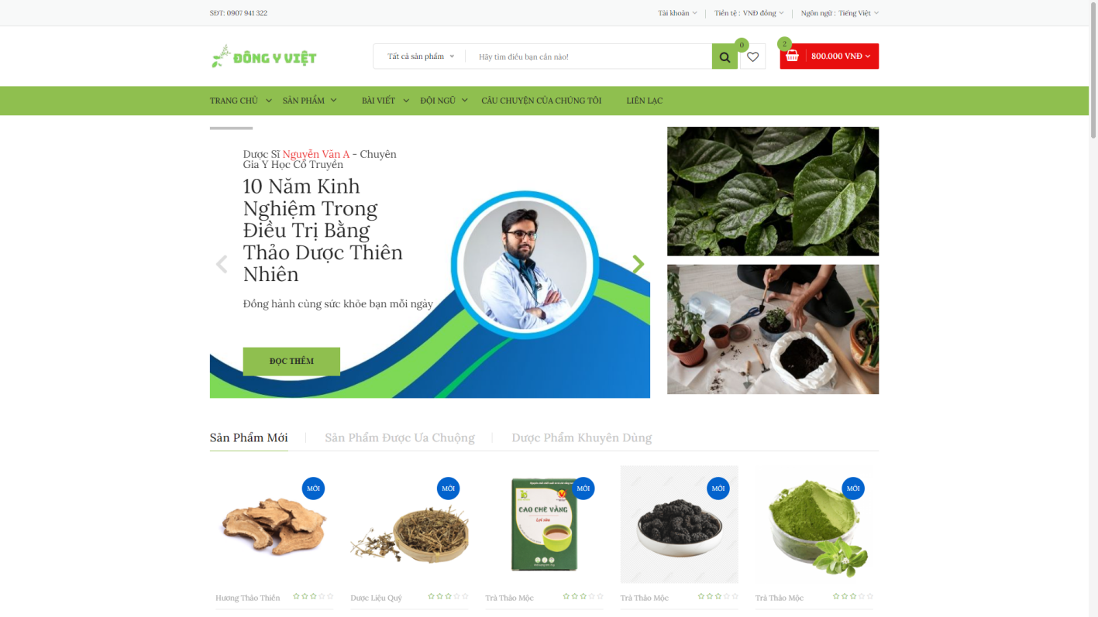

Figure 13: Home page 1

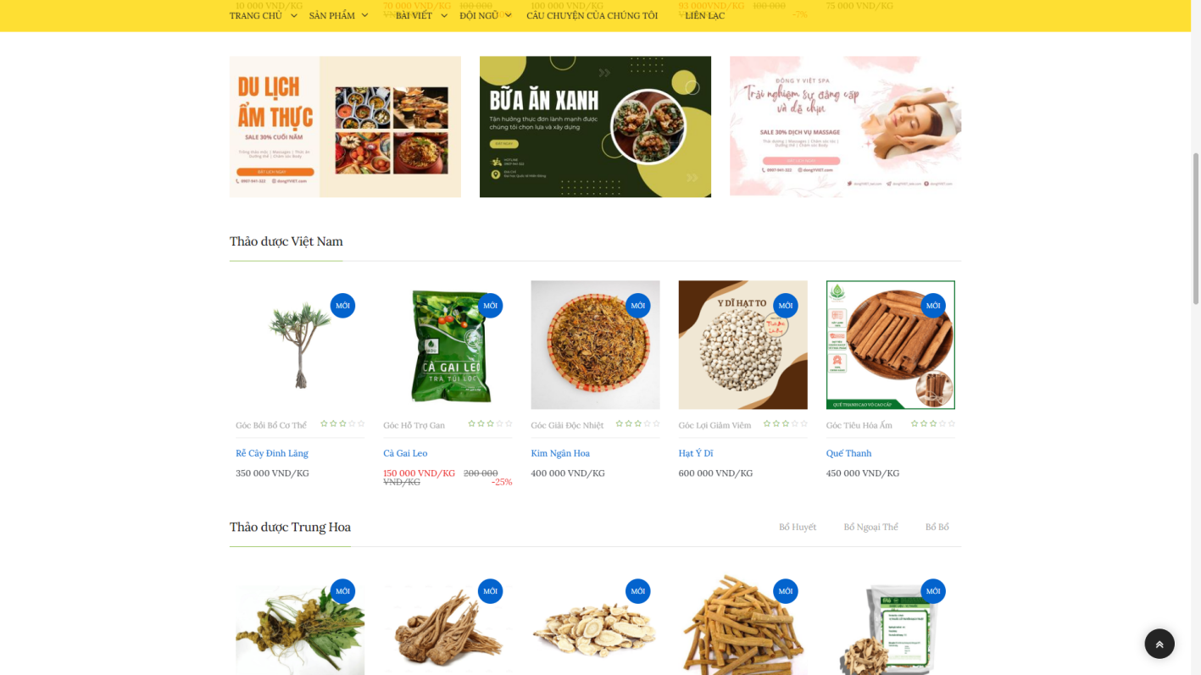Figure 14: Home page 2

The Home page features a top navigation bar with buttons for "Home," "Products," "Introduction," "Contact Us," and other categories. On the right, there is a search bar with a button, a notification button, and a cart view button. A prominent red "Order Now" button is also available for quick access to purchasing. The page includes a banner with information about an expert in traditional herbal treatments, as well as sections highlighting new products, recommended products, and promotional items. The layout prioritizes user accessibility and emphasizes key product categories.

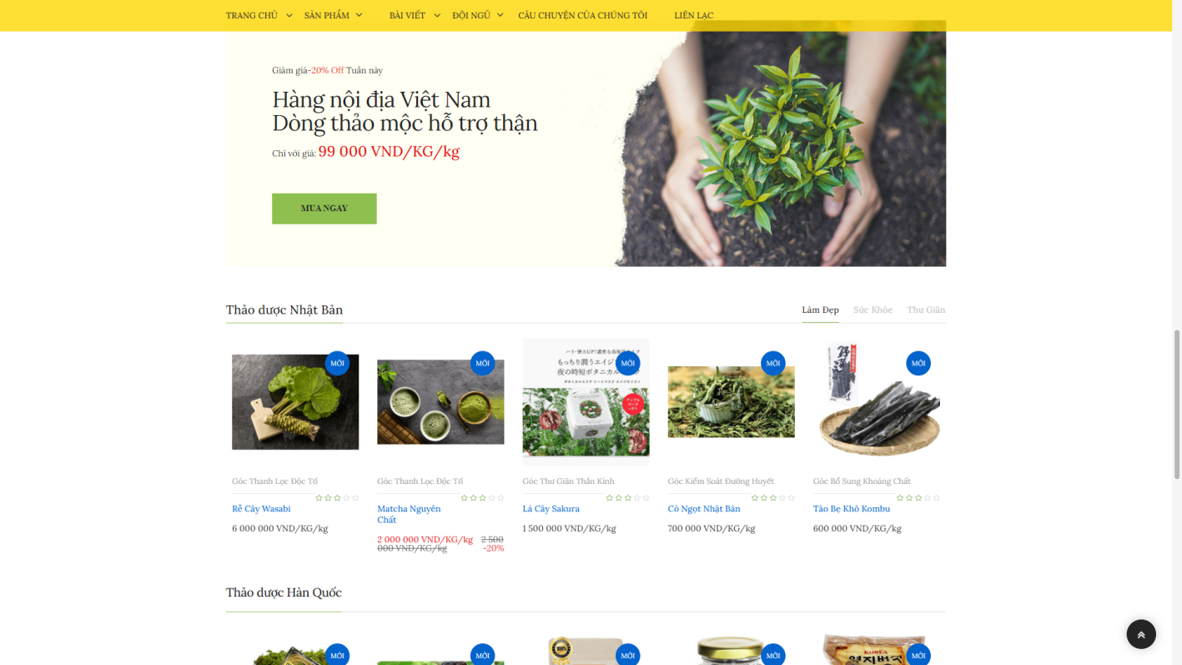Figure 15: Home Page 3

#### 4.4 Product Page

After choosing products, services, news. A new page contain a list of familiar information about what customers need will appear:

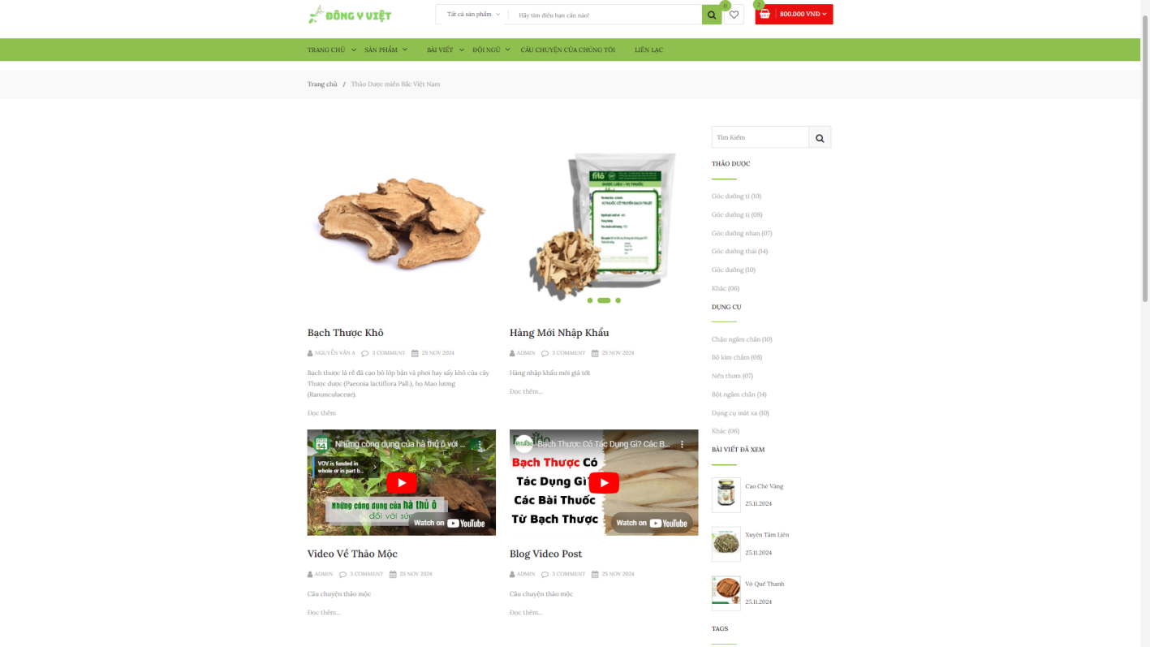Figure 16: List Product

**4.4.1 Product Page**

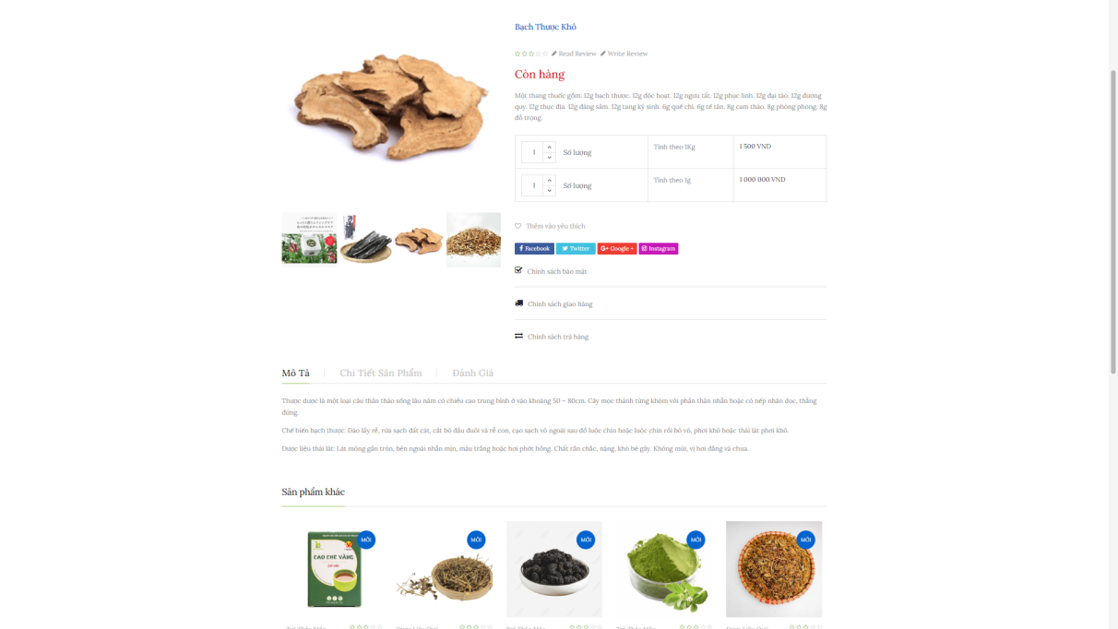Figure 17: Product Page

The page features the same navigation tab on the left and top bar as the Home page. In the center, there’s a table displaying the product list, showing all relevant information about the products stored in the database. At the bottom there are as well as 3 buttons for 3 functions: Describe Product, Product’s detailed, and writing Review.

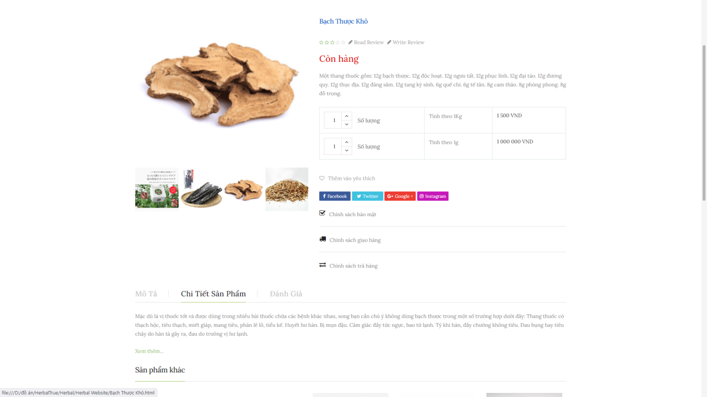Figure 18: More detailed product

After Clicking Product detailed and go Find more. It will lead to a new page which contains detailed information about product

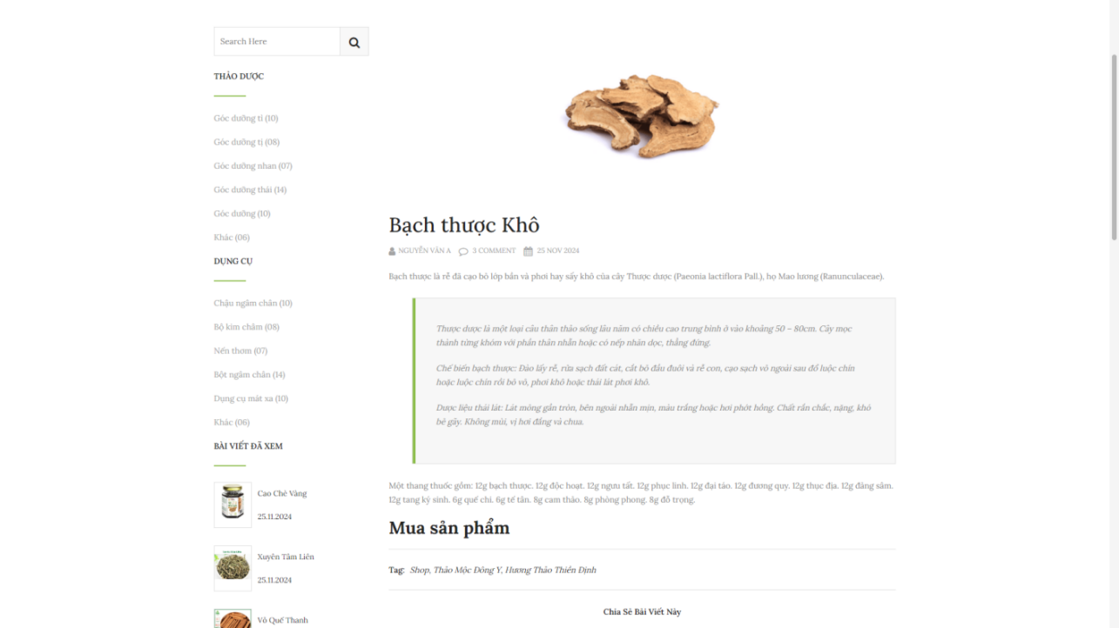Figure 19: Product Information

In Product Information Page, there a list of information about product and comment from another customers. Doctor, System User and customers can chat and discuss .

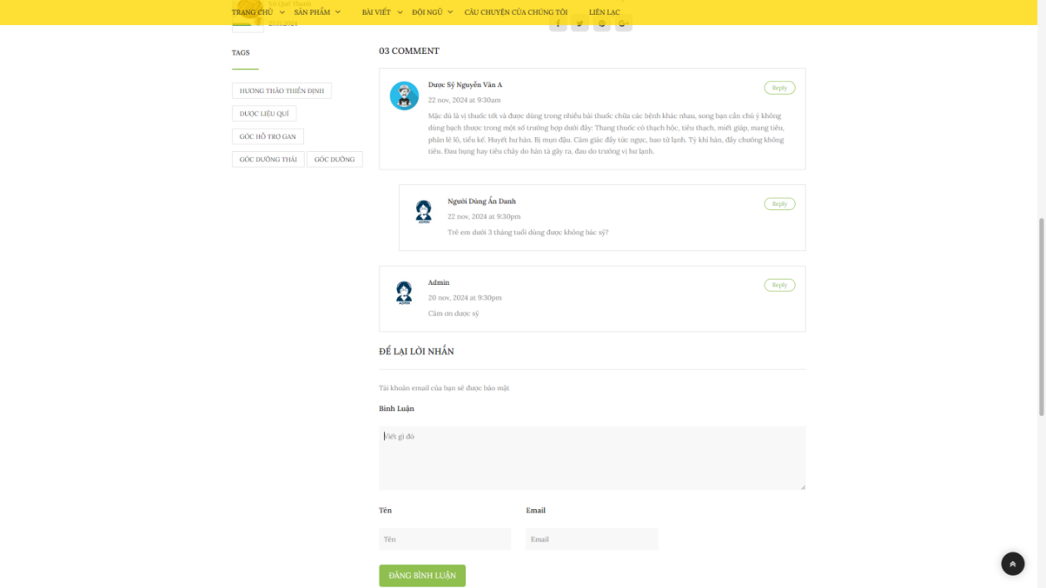Figure 20: Discuss and Share Product

You can also read review or give feedback after you purchase product. The name and Email are required but another user do not see yours.

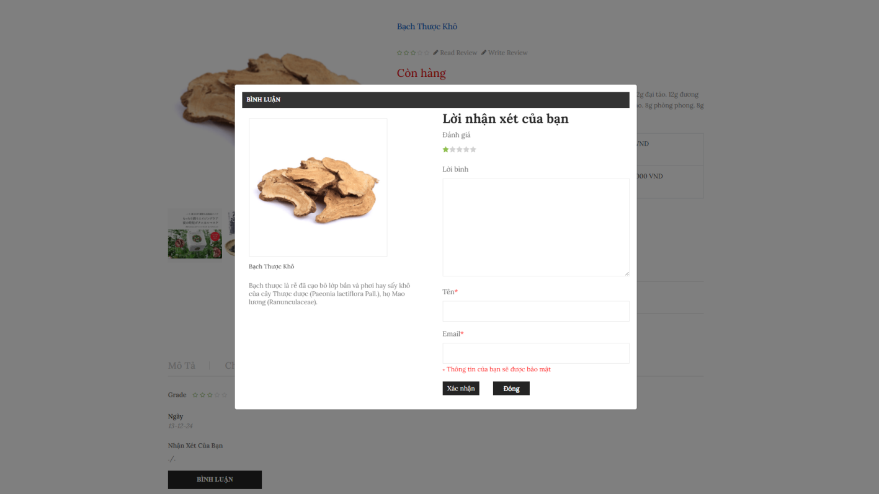Figure 21: Review

All customer information will be hidden in the review. Only name will appear. If doctor, system user or another customers reply, user will receive announcement through email

**4.4.2 News about Herbal**

Daily story, newspaper will be updated by System User. System User handle most about update information about news, services.

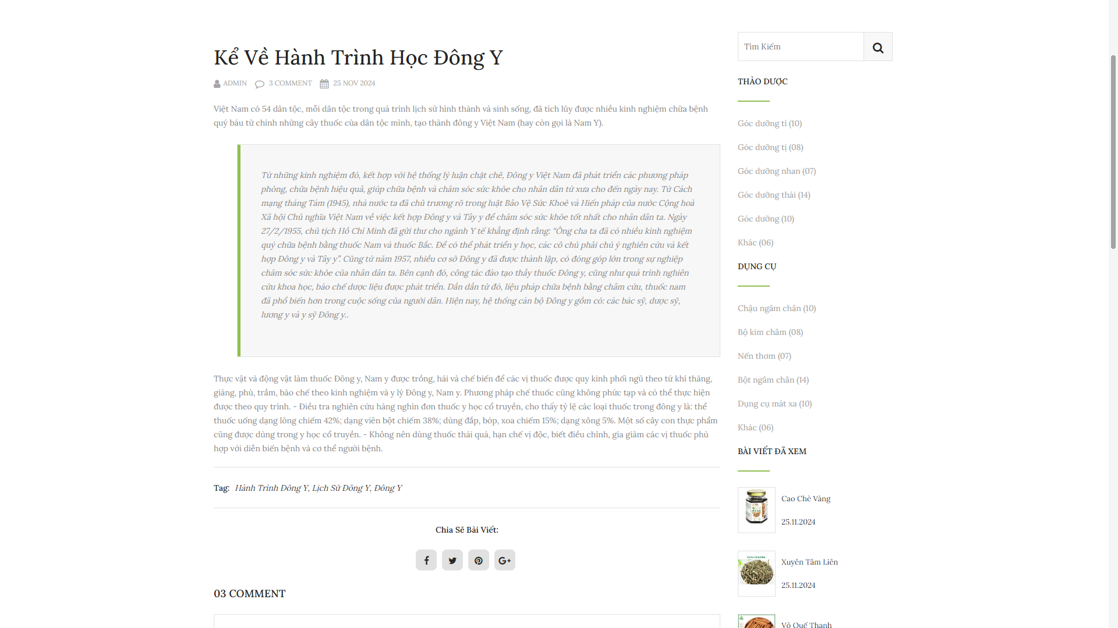Figure 22: Newspaper about Herbal

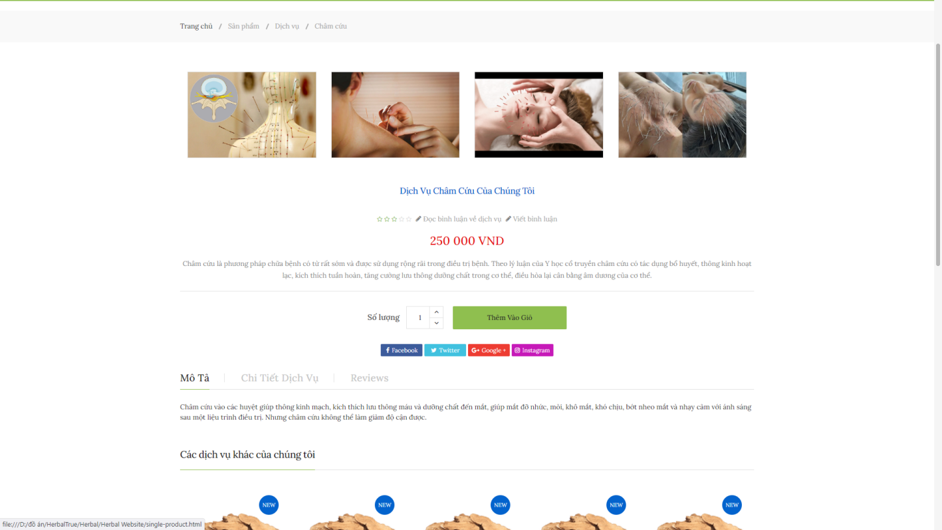 Figure 23: Service Cham Cuu

**4.4.3 Services**

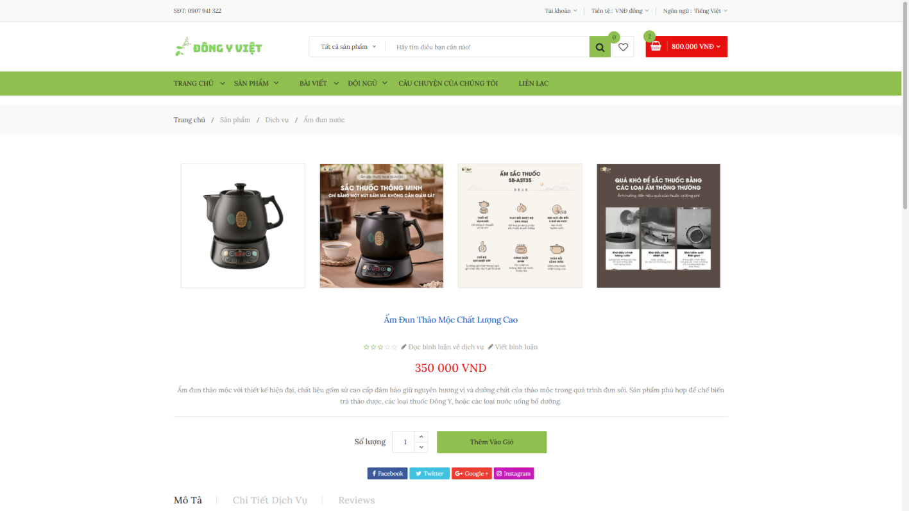Figure 24: Product Item

After add to cart. All services, products will appear. User can change the quantity and the sum of money will automatically change due to it. With button Update cart will enhance the experience more smooth. It will refresh and check the voucher to calculate the money customer have to pay.

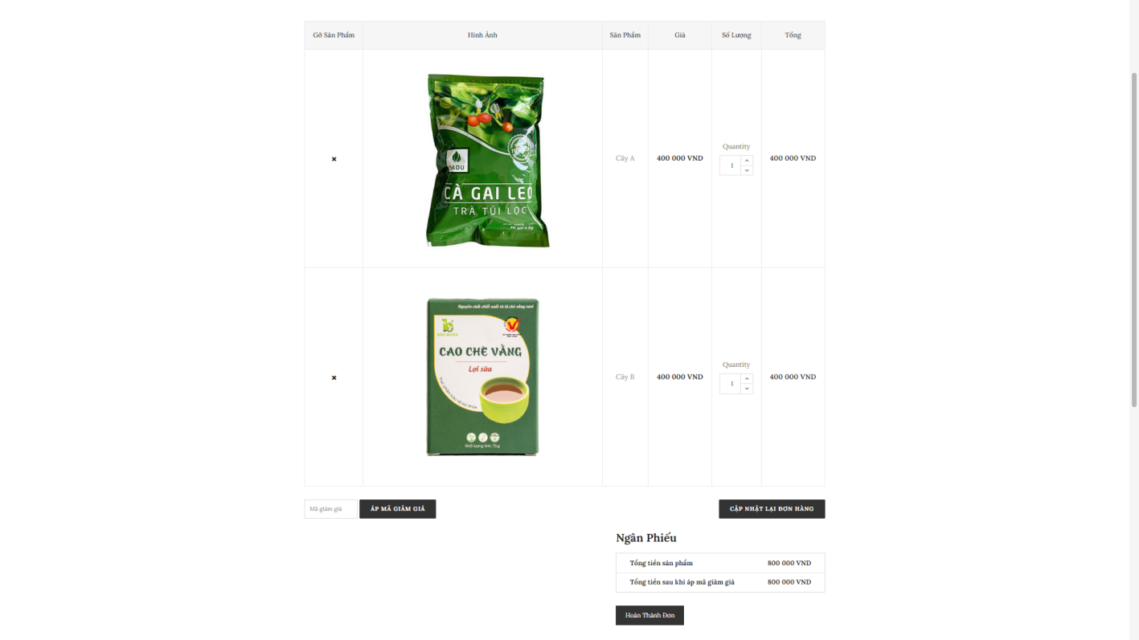

Figure 25: Add to Cart

**4.5 CRUD**

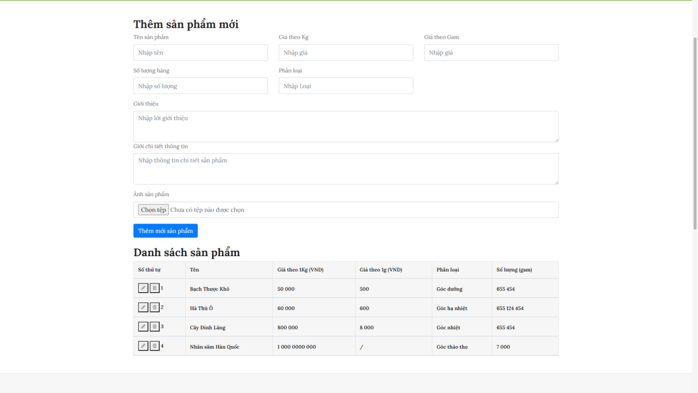Figure 26 :CRUD Product Page

As you can see, here in the Add new Product page, the selected Product’s properties and attributes is shown here in the input fields. After Add new Product. The new one will appear in Product List below. The id will automatically raise plus 1 each time add new one. Name, Price, Category, Storage will be listed near by.

Contact us page is where user can find the store on Google Map. Page contain information about Herbal shop like: address, hotline, Email, GPS. User can send request, report.

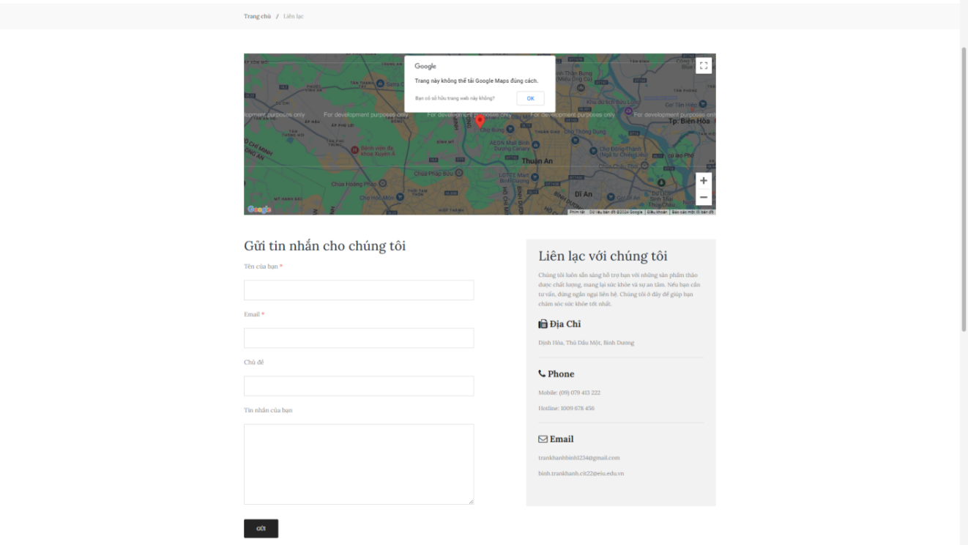Figure 27: Contact us Page

#### 4.6 Login Page - Sign up Page

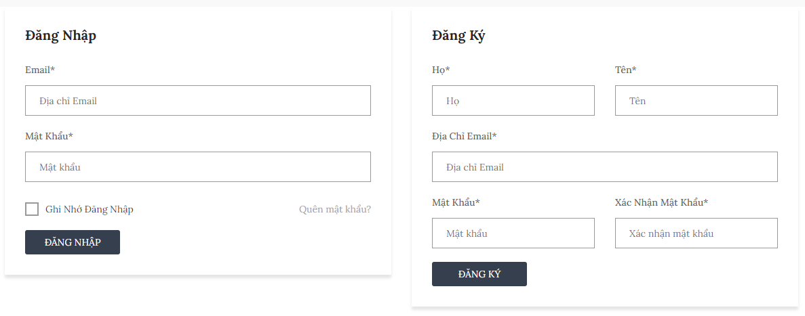

Figure 28: Login page

The Login Page - Sign up Page functionality offers a secure entry point for users, ensuring data protection. The Forgot Password feature aids in account recovery, enhancing user experience and system accessibility. The Remember Password features enhancing user experience speed to access shopping time.

**CHAPTER 5. CONCLUSION AND FUTURE WORKS**

* 1. **Conclusion**

In conclusion, the Herbal Website project successfully achieved its primary objective of implementing essential CRUD functionalities for managing herbal products and services. The current version of the platform allows users to create, view, update, and delete product listings seamlessly, providing a user-friendly interface that meets basic management needs.

Throughout this project, we gained valuable experience in web development, particularly in integrating RESTful APIs to connect the front-end and back-end, ensuring smooth data management. While the project focuses on fundamental functionalities, the development process provided a solid foundation for adding more advanced features in the future.

The challenges encountered during this phase, such as database design and system integration, helped us deepen our understanding of core web development concepts. Feedback from supervisors further guided us in refining the platform and improving its usability. This milestone not only signifies the progress of the project but also highlights our growth as developers in building functional web applications tailored to specific use cases.

* 1. **Future works**

Building on the current foundation, future phases of the Herbal Website project aim to enhance the platform's functionalities and user experience. Key areas for improvement and expansion include:

* **Improved CRUD Operations**: Optimize the existing CRUD system for better performance and ensure a smoother user experience, including more robust data handling and error messages.
* **Data Validation and Error Handling**: Strengthen input validation to minimize errors and improve the accuracy of stored data.
* **Enhanced User Interface**: Refine the UI to make it more intuitive and responsive, ensuring accessibility across different devices and screen sizes.
* **Search and Filtering Capabilities**: Add advanced search and filtering options to help users navigate products and services more efficiently.

These enhancements will transform the Herbal Website into a comprehensive solution for managing herbal products and healthcare consultations, meeting the evolving demands of its users. By addressing these future improvements, the platform can cater to a broader audience and deliver an even more impactful experience.

# REFERENCES

1. “ Top 10 website bài thuốc dân gian ‘đông y chân truyền”

**<https://10hay.com/top-list/10-website-bai-thuoc-dan-gian-dong-y.html>**

1. B. Lawson, R. Sharp, *Introducing HTML5*, 2012
2. D. R. Brooks, *An Introduction to HTML and JavaScript: for Scientists and Engineers, 2007*
3. R. Mistry, S. Misner, *Introducing Microsoft SQL Server 2014*, 2014.
4. **Spurlock, Jake.** Bootstrap: Responsive Web Development. O'Reilly Media, 2013.

**https://archive.org/details/bootstrap0000spur**

1. **Teixeira, Pedro.** Professional Node.js: Building JavaScript-Based Scalable Software. John Wiley & Sons, 2012

**https://archive.org/details/proexpressjs0000mard**

1. **Mardan, Azat.** Pro Express.js: Master Express.js: The Node.js Framework For Your Web Development. Apress, 2014.